**BUSINESS CONSULTANCY BASED ON BARTER SYSTEM**

**An Engineering Project in Community Service**

**Phase – I Report**

***Submitted by***

**Team number: 61**

1. **19BCE10036 Shikhar Pandey**
2. **19BCE10057 Vedant Agrawal**
3. **19BCY10066 Shreyash Singh**
4. **19BCY10103 Patnala Sai Kiran**
5. **19BCY10140 Shivam Agrawal**
6. **19BCY10177 Krishna Agrawal**
7. **19BME10034 Mayank Nath Tiwary**
8. **19MIM10057 Naman Arora**

***in partial fulfillment of the requirements for the degree of***

***Bachelor of Engineering and Technology***



**VIT Bhopal University**

**Bhopal**

**Madhya Pradesh**

**December, 2021**



**Bonafide Certificate**

Certified that this project report titled “**Business Consultancy”** is the Bonafide work of 19BCE10036 Shikhar Pandey, 19BCE10057, Vedant Agrawal, 19BCY10066 Shreyash Singh, 19BCY10103, Patnala Sai Kiran, 19BCY10140 Shivam Agrawal, 19BCY10177, Krishna Agrawal, 19BME10034 Mayank Nath Tiwary and 19MIM10057 Naman Arora who carried out the project work under my supervision.

This project report (Phase I) is submitted for the Project Viva-Voce examination held on 10th December 2021.

**Dr. Praveen Lalwani**

**(Project Supervisor)**

**INDEX**

|  |  |  |
| --- | --- | --- |
| **S.no.** | **Title** | **Page no.** |
| **1** | INTRODUCTION   * 1. Motivation   2. Objective | 4 |
| **2** | LITERATURE REVIEW | 4 |
| **3** | TOPIC OF WORK  3.1 System Design  3.2 Working Principle  3.3 Expected Results | 5-7 |
| **4** | CONCLUSION | 7 |
| **5** | REFERENCES | 7 |

1. **INTRODUCTION**
   1. **Definition**

A simple example of a barter arrangement is a carpenter who builds a fence for a farmer. Instead of the farmer paying the builder $1,000 in cash for labor and materials, the farmer could instead recompense the carpenter with $1,000 worth of crops or foodstuffs.

Bartering is based on a simple concept: Two individuals negotiate to determine the relative value of their goods and services and offer them to one another in an even exchange. It is the oldest form of commerce, dating back to a time before hard currency even existed.

* 1. **OBJECTIVE**

Bartering is usually conducted directly between two parties; however, it may be done multilaterally through a trade exchange. Developed countries typically don’t engage in barters unless they’re done in association with the standard monetary system of your country, and even then, it is only practiced in rare instances.

In times of monetary crisis, a barter system is often established as a means to maintain the trading of goods and services as well as to hold a country functioning. This may occur if physical money is not available or if a country sees hyperinflation or a deflationary spiral.

1. **LITERATURE REVIEW**

Since the beginning of human history, people have been trading directly in goods and services in a trading system called trading.

The history of trade dates back to 6000 BC. Introduced by the Mesopotamian tribes, the trade was adopted by the Phoenicians.

Traditionally, trading systems were used in the local community.

For example, a farmer with eggs and milk may sell a baker to a local baker for a birthday cake and bread. The baker then uses milk and eggs to bake more bread, which he gives to an electrician to pay for his oven.

1. **TOPIC OF THE WORK**
   1. **SYSTEM DESIGN/ARCHITECTURE**

Mobile app architecture encompasses the techniques and practices necessary for building fully functional mobile apps. These techniques are composed in agreement with industry standards and client requirements. Well-structured mobile app architecture helps increase maintainability and expandability which limits

the business risks involved with app development.

Our barter system app architecture is designed in three main layers within an application.

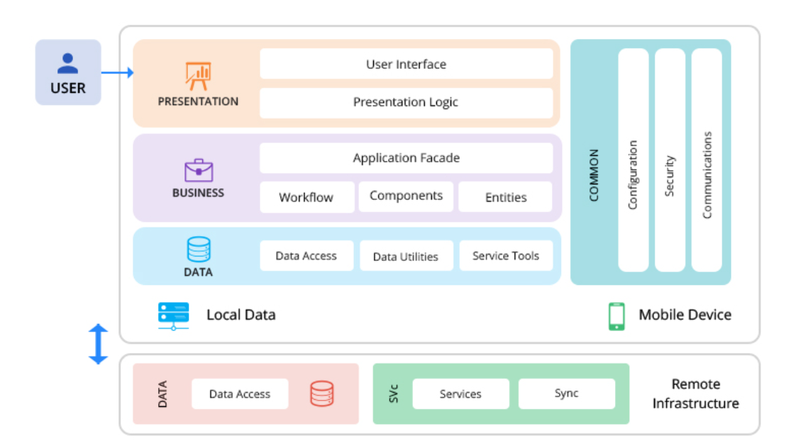

**Presentation Layer –** The presentation layer contains the user interface (UI) components and UI process components. At a high level, this layer defines the app’s presentation logic and how the product will look in the hands of its users.

**Business Layer –** This layer focuses on how to demonstrate the business identity to the user. The business layer is comprised of workflows, business entities, and components.

**Data Layer –** The data layer houses data-related components including access components, helpers, and utilities, as well as service agents.

Creating barter system application architecture would involve selecting multiple structural elements within a mobile app and its interfaces. One aspect is creating backend database design. The backend is a critical piece of app development because that’s where the value is. An app in itself is nothing if it doesn’t manipulate the right data in a timely fashion.

Now let’s consider the architecture of the barter system.

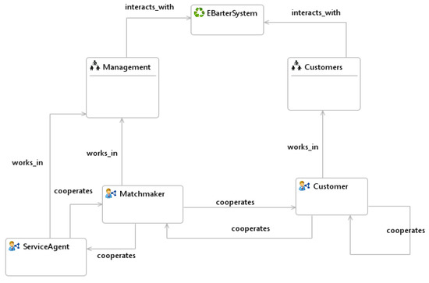

Considering the structure of the system, the barter system constitutes of two semantic web organizations called Customers organization which include Customer agents, and Management organization where the Matchmaker agent and Service Agent agents reside. It is worth indicating that entities given in this overview can be considered as stereotypes and in the real system implementation, there can be many instances of these entities. For example, there can be many agents of type Service Agent working in this system.

* 1. **WORKING PRINCIPLE**

Bartering is based on a simple concept: Two individuals negotiate to determine the relative value of their goods and services and offer them to one another in an even exchange. It is the oldest form of commerce, dating back to a time before hard currency even existed.

Our barter system application works on the principle based on the above bartering concept.

While the current senior generation bartered with the limited goods they had on hand (i.e., produce and livestock) or services they could personally render (i.e., carpentry and tailoring) to someone they knew.

Virtually any item or service can be bartered if the parties involved agree to the terms of the trade. Individuals, companies, and countries can all benefit from such cashless exchanges, particularly if they are lacking hard currency to obtain goods and services.

* 1. **EXPECTED RESULTS**

We expect our barter system app to let any two people communicate with each other and bartering to take place smoothly. It would greatly help all the clients using our application.

1. **CONCLUSION**

We're advancing in making our application.

There were a few new things that we had to learn for advancing in our project.

Currently we are working on the changes and suggestions that were made by the reviewers during the review.

Looking at the ongoing pace of the work, I think we would be able to make the app efficiently within the given period of time.

1. **REFERENCES**

* [barter system - Definition, Latest News, and Why barter system is Important? (cleartax.in)](https://cleartax.in/g/terms/barter-system#:~:text=In%20times%20of%20monetary%20crisis,hyperinflation%20or%20a%20deflationary%20spiral.)
* [Barter (or Bartering) Definition (investopedia.com)](https://www.investopedia.com/terms/b/barter.asp#:~:text=A%20simple%20example%20of%20a,worth%20of%20crops%20or%20foodstuffs.)
* [A Day in the Life of a Mobile App Architect at Clearbridge Mobile](https://clearbridgemobile.com/day-in-life-mobile-app-architect/)
* [Applied Sciences | Free Full-Text | Development of Semantic Web-Enabled BDI Multi-Agent Systems Using SEA_ML: An Electronic Bartering Case Study | HTML (mdpi.com)](https://www.mdpi.com/2076-3417/8/5/688/htm)